**Task 1**

**Create a lambda function to start, stop and terminate a running EC2 instance. Also, verify the logs generated by the lambda in the Cloudwatch logs to check whether the lambda execution is done properly.**

-

-I have already created an ec2 instance in Console.

-Create a lambda function & give it permissions like **FullEC2Access** and **AWSLambdaBasicExecutionRole**

-If you will not give the function **AWSLambdaBasicExecutionRole** role then we won’t be able to watch the lambda logs in cloudwatch.

-Write the code for lambda function & then test it.

-After successful run of the function go to monitoring section of lambda function and then go to **view logs in cloudwatch** section

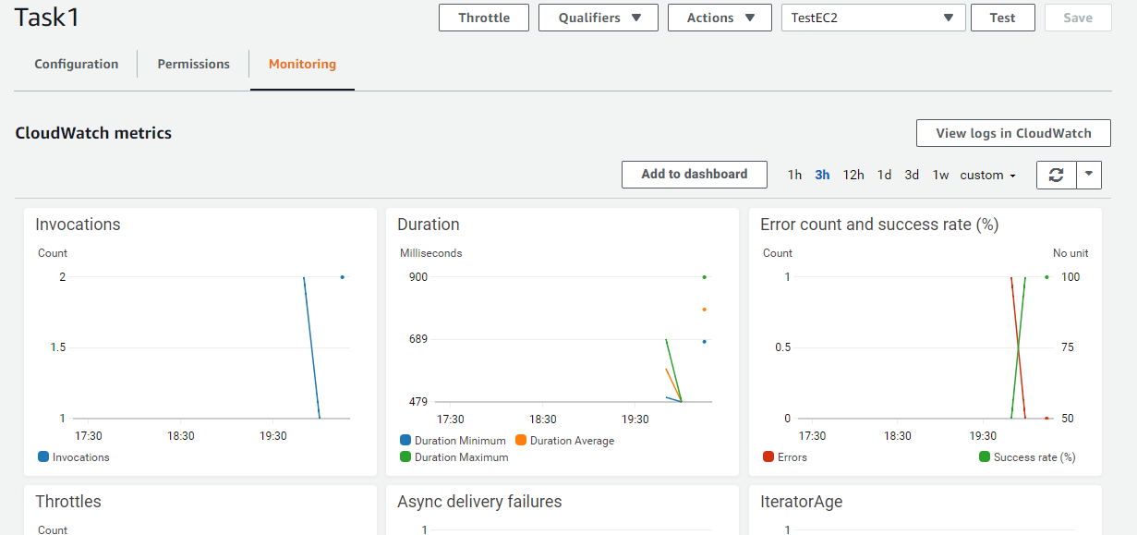

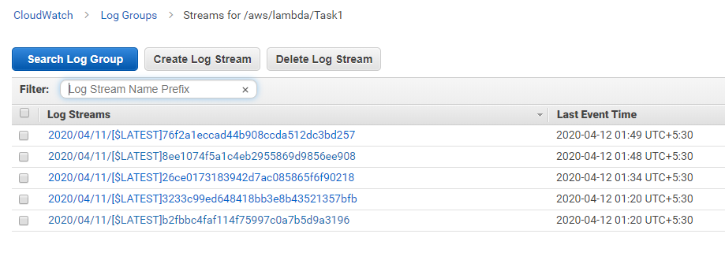

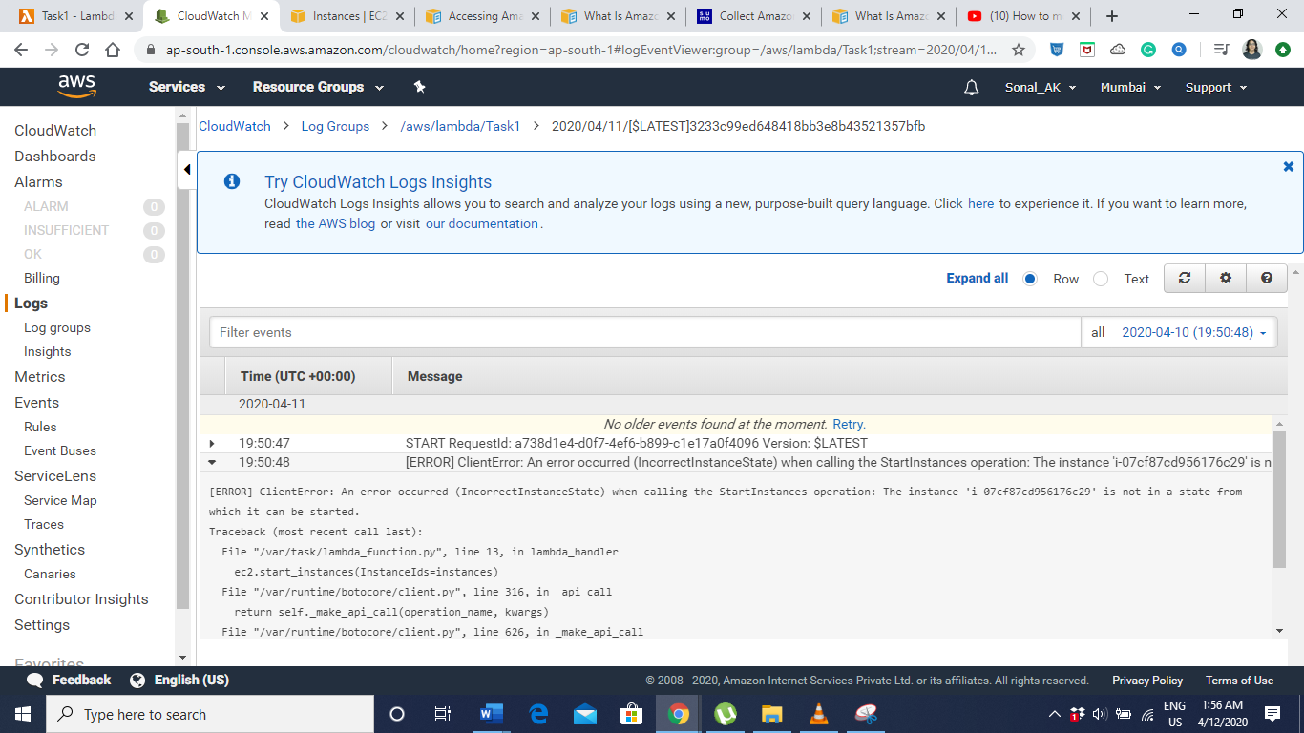

You can track what error were present, what went wrong.